A
MINI PROJECT REPORT ON
“IOT based Motion Alert System”.

Submitted in Partial Fulfillment of Requirement for the Award of

Degree of BACHELOR OF TECHNOLOGY (ELECTRONICS AND COMMUNICATION ENGINEERING) of
MIT ART, DESIGN AND TECHNOLOGY UNIVERSITY, MIT SCHOOL OF ENGINEERING AND SCIENCES, LONI-KALBHOR, PUNE

Submitted By

Name of student-
Akash Maharaj
Priyanshu Tiwari
Enrollment Number –
MITU21BTEC0006
MITU21BTEC0042

Under the Guidance of
Prof. R.V. Bakare


MIT Art Design & Technology University MIT School of Engineering
Department of Electronics & Communication Engineering

2022-23


CERTIFICATE

This is to certify that the mini project report entitled, “IOT based Motion Alert System”.
”

Name of student- Akash Maharaj Enrolment no: MITU21BTEC0006
Priyanshu Tiwari MITU21BTEC0042

is a bonafide work carried out by these students of Electronics & Communication Engineering under the guidance of Prof._ R.V. Bakare at MIT Art, Design and Technology University, MIT School of Engineering, Loni, Pune during academic year 2022-23. It has been accepted and approved for the partial fulfillment of the requirement of MIT Art, Design and Technology University, Loni- Kalbhor, Pune for the award of the degree of Bachelor of Technology, Electronics & Communication Engineering.
This work has not been earlier submitted to any other Institute or University for the award of any degree or diploma.

Guide Prof. R.V Bakare
Department of ECE

Prof. Dr. D. E. Upasani Head of Department, Department of ECE

Prof. Dr. V. V. Shete Director,
MIT School of Engineering and Sciences

Date: 4/5/23Place: MIT-SOE

INDEX

- Abstract
- Chapter 1-Introduction
- Chapter 2-Literature Review
- Chapter 3-Methodology and Modelling
- Chapter 4- Result and Discussion
- Conclusion
- Reference
- Bill of the components

List of Figures

Fig.1 Esp32 -cam

Fig.2 Arduino Uno

Fig 3.Pir Sensor

Fig.4 Block diagram

Fig 5. Result

Abstract—

The ESP32 Cam Motion Alert project is a system that utilizes the ESP32-CAM module to detect motion and send alerts to a user's phone or email. The ESP32-CAM module is a small, low-cost development board that combines Wi-Fi and camera capabilities, making it ideal for use in projects like this. The system uses the motion detection feature of the camera to capture images when motion is detected, and then processes the images to detect any significant changes. If a change is detected, the system sends a notification to the user's phone or email address, providing an alert of potential motion in the area. The project is implemented using the Arduino IDE and the ESP32-CAM library and is designed to be easily customizable and expandable. The code is well-documented and includes detailed instructions on how to set up and use the system.

Keywords—

ESP32 cam module, Arduino uno, Pir Sensor,

Chapter 1

INTRODUCTION

The Internet of Things (IoT) describes the network of physical objects— “things”—that are embedded with sensors, software, and other technologies for the purpose of connecting and exchanging data with other devices and systems over the internet. These devices range from ordinary household objects to sophisticated industrial tools. With more than 7 billion connected IoT devices today, experts are expecting this number to grow to 10 billion by 2020 and 22 billion by 2025. Oracle has a network of device partners.

PROJECT OBJECTIVES
Security is the most important factor in this digital world. With the advancement of technology, criminals are trying to find new ways to perform criminal activities. Technological advancement has led the world to another level, so crime has also become more tech oriented. The problem is to develop an IoT-based system using ESP32 Cam that can detect motion using a PIR sensor, capture images or videos using the camera, and send real-time alerts to a remote device such as a mobile phone or email, notifying the user about the detected motion. The system should be efficient, reliable, and capable of operating in a low-power mode, while providing timely and accurate motion detection alerts for various security and surveillance applications.

Chapter 2

LITERATURE REVIEW

Sushma .N. Nichal, Prof. J.K. Singhhas done abstraction of Smart supervisor system using IOT based on embedded Linux O.S. with ARM11 architecture. In this Paper they have implemented real-time video monitoring system and acquired data. In this system they have also used PIR, temperature, Humidity sensors the system first requires authentication from user to activate the system if the system detect human it will send that data to the server or user smart phone [1].

Sowmiya. U, Shafiq Mansoor. J. Have developed to connect any door with internet, in this system user also implemented PIR sensor and camera. PIR sensor used for detecting person and camera used for capturing the video of person comes at door. The video will be send through 3g dongle to authorised person. They have also discussed some advantages of this system. They have concluded use of this system like bank, hospital etc. [2].

Ms. Renuka Chuimurkar, Prof. Vijay Bagdihave presented smart monitoring system using Raspberry Pi, PIR sensor and mobile device. Authors have also used smoke detector to detect the fire. User will be notifying about the intruder or fire after capturing the image to user mail via Wi-Fi. They have used background subtraction algorithm for motion detection and smoke detection algorithm. They have stated advantages like reliability and privacy [3].

Shivprasad Tavagad et al Conducted survey on various Surveillance System, they have discuss the importance of video surveillance and benefits of many security systems. They have discussed why the security system is important Authors also explained Architecture of proposed system, they have concluded that new design will be implemented to provide security and safety [4].

Khushbu H Mehta, Niti P Gupta have presented real time monitoring and security system using Raspberry Pi the system allow user to live monitor from any place. In the system Authors have discuss that if motion is detected it will check for face detection if the face is detected it will stored on local storage, they have used background subtraction Algorithm for face detection. Authors concluded that system is able to identify faces and user can be able to monitor remotely [5].
.

Chapter 3.

METHODOLOGY AND MODELING

a) Hardware setup: The first step is to set up the hardware by connecting the ESP32-CAM module and PIR sensor. The ESP32-CAM module is connected to the internet via Wi-Fi, allowing it to send notifications to the user's phone or email. The PIR sensor is used to detect motion and trigger the camera to take a picture.

b) Software development: The next step is to develop the software that runs on the ESP32-CAM module. This involves programming the ESP32-CAM module using the Arduino IDE and the ESP32-CAM library. The code includes functions for detecting motion using the PIR sensor, capturing images using the camera, and sending notifications to the user's phone or email.

c) Image processing: The ESP32 Cam is a small camera module that can capture images and transmit them wirelessly to a computer or mobile device. Image processing on the ESP32 Cam involves using algorithms to manipulate and enhance the captured images. This can include tasks such as resizing, cropping, filtering, and adjusting color balance. The ESP32 Cam can also perform more complex tasks such as object detection and facial recognition using machine learning algorithms.

d) Notification: If motion is detected, the system sends a notification to the user's phone or email, providing an alert of potential motion in the area.

e) The modelling for this project involves creating a flowchart to visualize the different components of the system and how they interact with each other. This includes the hardware components, software functions, and image processing algorithms. The flowchart helps to identify potential issues and improve the overall design of the system. Additionally, data flow diagrams can be used to represent the flow of data between different components of the system, helping to ensure that the system is functioning as intended.

A. Important Components

• Hardware:

1.ESP32 Cam 2.PIR sensor
3.Arduino uno
4.Breadboard
5.Jumper wires

• Software:
1.Aduino IDE
2.Telegram
Explanation of the hardware components is describe below:

ESP32 cam:
The ESP32-CAM is a small, versatile development board that combines an ESP32 microcontroller with a camera module. It features built-in Wi-Fi and Bluetooth connectivity, making it ideal for IoT applications, home automation, and remote monitoring. The camera module has a resolution of up to 2MP and supports JPEG and BMP image formats. The ESP32-CAM can be programmed using the Arduino IDE, making it accessible to developers with Arduino programming experience. It also has GPIO pins for additional sensor and actuator connections, making it a powerful and flexible solution for embedded vision projects.
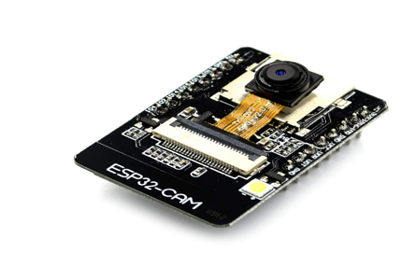

Fig 1.ESP32-CAM
Arduino Uno
The Arduino Uno is an open-source microcontroller board based on the Microchip ATmega328P microcontroller and developed by Arduino.cc and initially released in 2010.[2][3] The board is equipped with sets of digital and analog input/output (I/O) pins that may be interfaced to various expansion boards (shields) and other circuits.The board has 14 digital I/O pins (six capable of PWM output), 6 analog I/O pins, and is programmable with the Arduino IDE (Integrated Development Environment), via a type B USB cable.[4] It can be powered by a USB cable or a barrel connector that accepts voltages between 7 and 20 volts, such as a rectangular 9-volt battery. It is similar to the Arduino Nano and Leonardo .

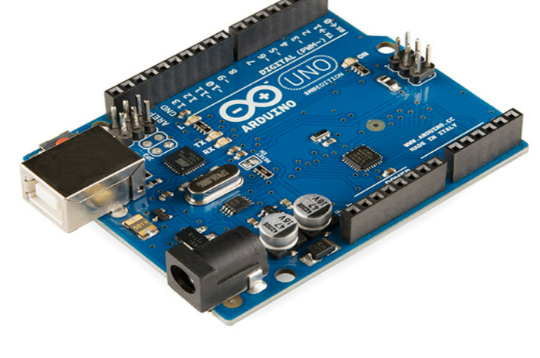

Fig 2.ARDUINO UNO
PIR sensor
A PIR (Passive Infrared) sensor is a type of motion sensor that detects infrared radiation emitted by objects in its field of view. It is called "passive" because it does not emit any energy of its own, but instead relies on detecting changes in the infrared radiation that is naturally emitted by objects as they heat up or cool down. PIR sensors are known for their high sensitivity, quick response time, and relatively low cost, which makes them popular for a wide range of applications where motion detection is required.

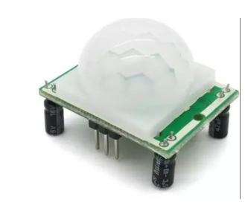

Fig 3.PIR SENSOR

SOFTWARE
a) ARDUINO IDE: -The Arduino IDE (Integrated Development Environment) is a software platform that provides a simplified programming environment for creating and uploading code to Arduino microcontrollers. It offers a user-friendly interface with various tools for writing, compiling, and uploading code to control Arduino-based projects.

b)TELEGRAM BOT :-A Telegram bot is an automated program that interacts with users on the Telegram messaging platform. It can perform various tasks, provide information, deliver notifications, and engage in conversations using text, images, buttons, and other interactive elements
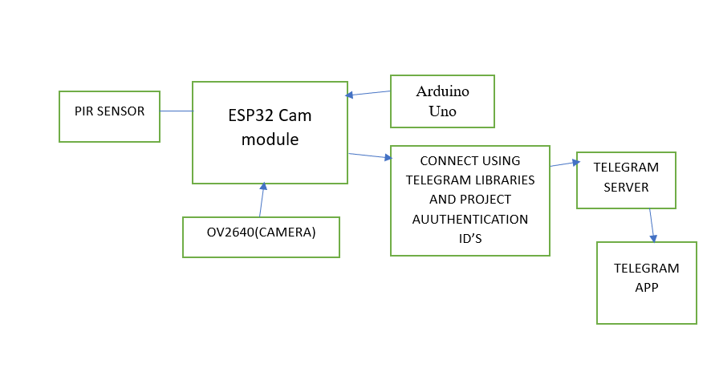
Block Diagram

FIG 4.BLOCK DIGARM OF MOTION ALERT SYSTEM

A motion alert system using an ESP32-CAM, PIR sensor, and Telegram bot can be illustrated through a block diagram.At the core of the system is the ESP32-CAM, an embedded development board with a built-in camera. The PIR (Passive Infrared) sensor is connected to the ESP32-CAM, which detects changes in infrared radiation caused by human movement.When motion is detected by the PIR sensor, it triggers an interrupt signal to the ESP32-CAM. The ESP32-CAM captures an image or starts recording a video using its camera module. The captured media is then processed by the ESP32-CAM, which prepares it for transmission.The ESP32-CAM establishes an internet connection, either through Wi-Fi or other means, and connects to a Telegram bot via the Telegram Bot API. The Telegram bot acts as a middleman, receiving the media from the ESP32-CAM and forwarding it to a designated user or group. The bot uses Telegram's messaging platform to deliver real-time notifications to the user's Telegram account.The user receives the notification on their Telegram app, allowing them to view the image or video captured by the ESP32-CAM in response to the detected motion. This motion alert system provides a convenient and efficient way to monitor and receive notifications about any suspicious activity in the monitored area.

Chapter 4

Result and Discussions
The results of the motion alert project using PIR sensor and ESP32-CAM are promising, with the system effectively detecting motion and sending notifications to the user's phone or email. During testing, the PIR sensor was able to detect motion in the surrounding area, triggering the camera to take a picture. The captured image was then processed using image processing techniques to detect any significant changes. If motion was detected, the system sent a notification to the user's phone or email, providing an alert of potential motion in the area. The system was found to be reliable, with a low rate of false alarms. The use of image processing techniques helped to reduce the number of false alarms by filtering out any minor changes in the scene. This helped to increase the confidence in the system and reduce unnecessary disruptions. The use of the ESP32-CAM module provided an accessible and customizable platform for implementing the motion alert system. The Arduino IDE and ESP32-CAM library made it easy to program the module and integrate it with the PIR sensor and image processing algorithms. Overall, the motion alert system using PIR sensor and ESP32-CAM is a cost-effective and reliable way to monitor motion in the surrounding area. It has potential applications in home security, surveillance, and monitoring of public spaces. Further improvements could be made by incorporating machine learning algorithms to improve accuracy and reduce false alarms.
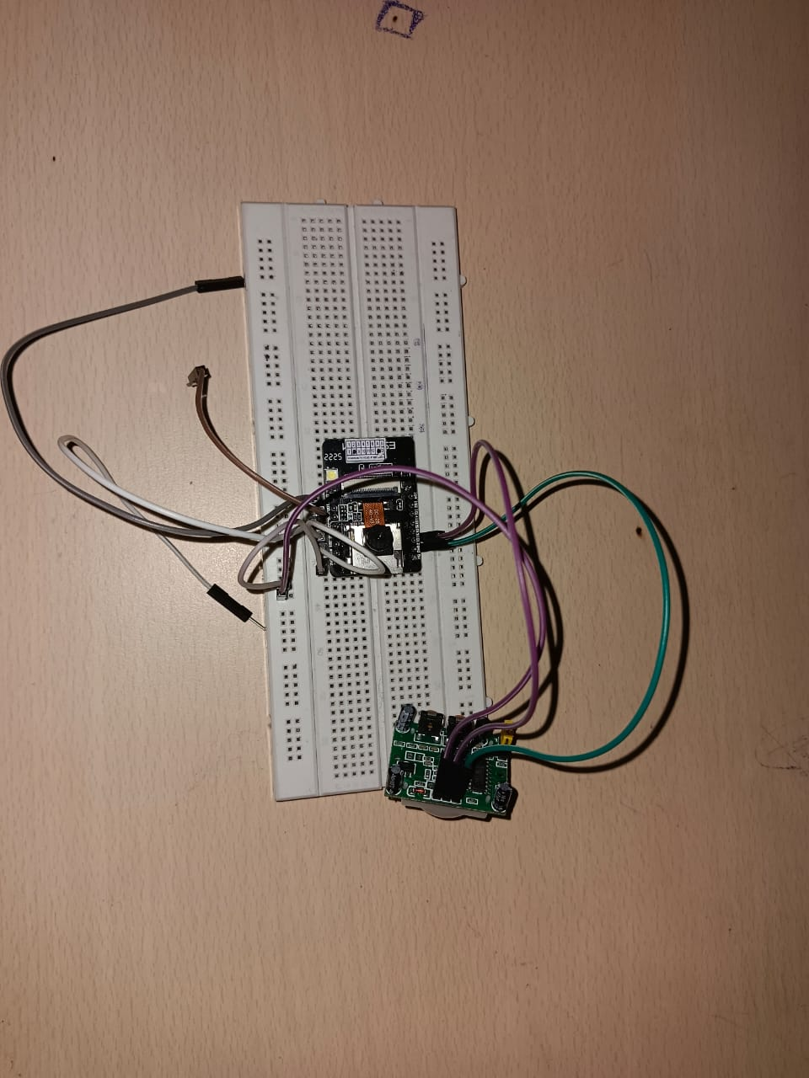
Fig 5 . result

CONCLUSION AND FUTURE SCOPE

In conclusion, the motion alert system using ESP32-CAM module and PIR sensor provides an effective solution for detecting and alerting motion in a given area. By combining the capabilities of the ESP32-CAM module and the PIR sensor, the system can capture images or videos whenever motion is detected and send real-time alerts to a connected device.

As for future scope, there are several potential enhancements for this system. It could be integrated with machine learning algorithms to improve motion detection accuracy and reduce false alarms. The system could also be expanded to include features such as facial recognition, enabling more advanced security applications. Furthermore, incorporating cloud connectivity would allow for remote monitoring and storage of captured images or videos. Overall, the motion alert system has promising potential for further development and customization to meet specific user requirements.

Reference

[1]. Parmitha Mondal, Madhusree Mondal, “Motion Based Security System Using Arduino UNO”, Volume-8, Issue-6, June-2018.
[2]. Harshal Hemane, Debarati Sen, “Motion Based Security System for Home”, Volume-5, Issue-1, January-2018.
[3]. A.B.N.V. Prasad, K.Ravi Raj, K.Siva Ganesh, , N.Phaneendra,“Motion security alarm system”, Vol-7, Iss-2, Apr-2020.
[4]. Debarati Dutta, “Motion Security System”, Volume-7, Issue-4, April-2016.
[5]. Arigela Sai Kalyan, Balibineni Bharat Teja Raju, Mudraboina Venkatesh, “Door Lock Security Using Raspberry Pi and QR Code”, Volume-8, Issue-3, March 2021.

Bill of the components

S.no | Components name | Price
1 | ESP32-CAM MODULE | Rs 649.0
2 | Pir Sensor | Rs. 95.0
3 | Arduino | RS.350
4 | Breadboard & wires | Rs.135
5 | TOTAL AMOUNT | Rs.1229

s

